Recertification Verification Recommendation List Content

Overview
The recertification verification recommendation list is a 2 screen intervention that shows personalized verification recommendations based on a client’s answers in the Recertification flow. The intervention replaces the final “submitted” screen of the Recertification flow with 2 screens:
- Submitted/What’s Next | - Submit proof now
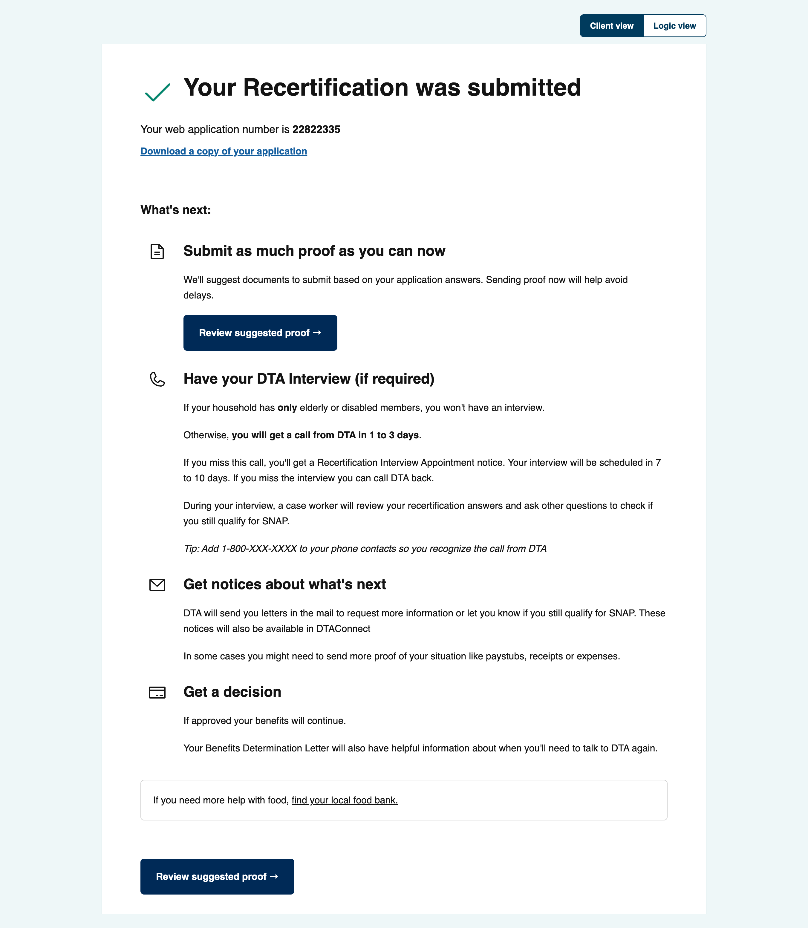 | 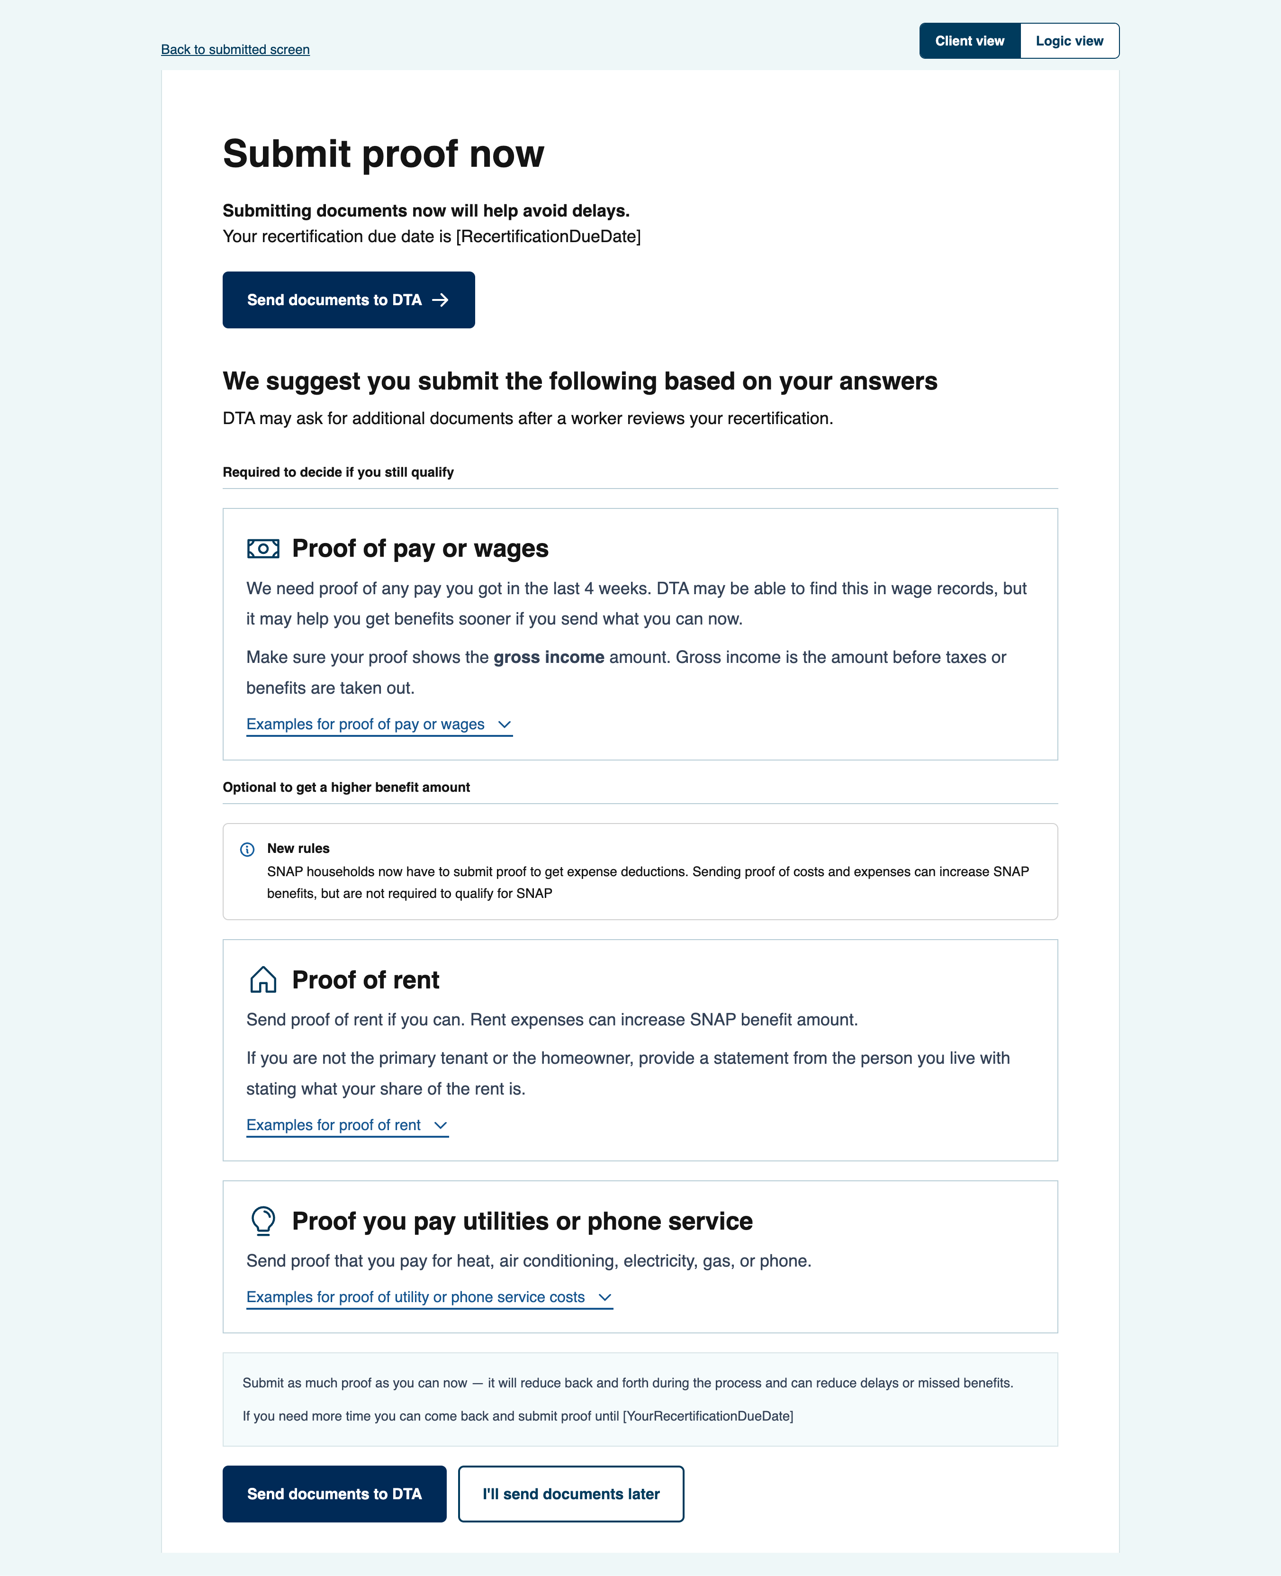

- “Submitted/What’s next”
  - This screen contains helpful information to set expectations about what’s coming next in the process and prompts clients through a call-to-action button to “Submit proof now”. That button takes clients to the 2nd screen of our pilot
- “Submit proof now”
  - This screen contains suggestions about submitting verifications and a call-to-action button to “Send documents to DTA”.
  - The screen also includes a dynamic list of recommendation “cards” based on a clients previous answers. Each recommendation card includes the following content ingredients
    - Card title: This is the header of the recommendation [“Proof of…”]
    - Body copy: Describes the verification requirement and includes key terms to ease understanding. This copy is largely drawn from current client facing DTA content.
    - Example toggle label: The reveal/toggle text that the clients can click to open helpful information
      - Example toggle text: The text inside the reveal/toggle component that lists examples largely drawn from VC-1 text
    - Additional toggle label (if applicable): The label text for any additional ‘helper’ content. Clients can click this to open additional helper content. This content is shown only when a client has indicated self employment income, dependent, and/or medical expenses
      - Additional toggle text: The text inside the additional reveal/toggle component that shows helper content.

Screen 1: Submitted/What’s next screen
[Screen copy begins]
Your Recertification was submitted
Your web application number is XXXXXX
Download a copy of your application
What's next:
 Submit as much proof as you can now
We'll suggest documents to submit based on your application answers. Sending proof now will help avoid delays.
Button: Review suggested proof →
 Have your DTA Interview (if required)
If your household has only elderly or disabled members, you won't have an interview.
Otherwise, you will get a call from DTA in 1 to 3 days.
If you miss this call, you'll get a Recertification Interview Appointment notice. Your interview will be scheduled in 7 to 10 days. If you miss the interview you can call DTA back.
During your interview, a case worker will review your recertification answers and ask other questions to check if you still qualify for SNAP.
Tip: Add 1-800-XXX-XXXX to your phone contacts so you recognize the call from DTA
 Get notices about what's next
DTA will send you letters in the mail to request more information or let you know if you still qualify for SNAP. These notices will also be available in DTAConnect
In some cases you might need to send more proof of your situation like paystubs, receipts or expenses.
 Get a decision
If approved your benefits will continue.
Your Benefits Determination Letter will also have helpful information about when you'll need to talk to DTA again.
Highlight box: If you need more help with food, find your local food bank.

Button: Review suggested proof →

Screen 2: Submit proof now screen
[Screen copy begins]
Submit proof now
Submitting documents now will help avoid delays.
Your recertification due date is [RecertificationDueDate]
Button: Send documents to DTA
We suggest you submit the following based on your answers
DTA may ask for additional documents after a worker reviews your recertification.
Required for decide if you still qualify
[Recommendation cards dynamically populate below based on client answers/triggers (in grey]
Recertification answer/trigger | Wages selected
Card title | Proof of pay or wages
Body copy | We need proof of any pay you got in the last 4 weeks. DTA may be able to find this in wage records, but it may help you get benefits sooner if you send what you can now.  Make sure your proof shows the gross income amount. Gross income is the amount before taxes or benefits are taken out.
Example toggle label | Examples for proof of pay or wages
Example toggle text | • Recent pay stubs or statements (4 pay stubs if paid weekly, 2 pay stubs if paid biweekly)  • Payroll app screenshots (showing your name, the employer name, gross pay, dates, and hours worked)  • Employer statement or letter showing any pay you received and the number of hours worked  Note: We do not count earned income for students under 18 who are in school. You do not need to tell us about this income.
Additional toggle label | N/A
Additional toggle text: | N/A
EOTSS notes on source: | Rule ID: INC-001 | Source: All

Recertification answer/trigger | Still working at employer but income changed
Card title | Proof of changed income from current employer
Body copy | You said someone is still working but their income changed. Send proof that shows the new gross income amount or new schedule.  Make sure any income amounts shows the gross income amount. Gross income is the amount before taxes or benefits are taken out.
Example toggle label | Examples for proof of changed income from current employer
Example toggle text | • Recent pay stubs or statements  • Payroll app screenshot  • Employer statement  • Letter/text/email showing new hours, rate, or schedule
Additional toggle label | N/A
Additional toggle text: | N/A
EOTSS notes on source: | Rule ID: INC-019 | Source: Interim report; Recertification

Recertification answer/trigger | No longer working at employer
Card title | Proof that a job ended
Body copy | You said someone is no longer working at an employer. We need to know when the job ended, the reason the job ended, and any pay in the last 4 weeks.  Make sure any proof of pay shows the gross income amount. Gross income is the amount before taxes or benefits are taken out.
Example toggle label | Examples for proof that a job ended
Example toggle text | • Recent paystubs or statements showing gross income  • Letter from employer showing gross income  • Layoff notice or termination letter or email from an employer  • Copy of your unemployment claim or unemployment benefit information  • Other document showing when and why the job stopped  • if self employed: business records or statements showing when the income ended
Additional toggle label | N/A
Additional toggle text: | N/A
EOTSS notes on source: | Rule ID: INC-020 | Source: Interim report; Recertification

Recertification answer/trigger | Self-employment selected
Card title | Proof of self-employment income
Body copy | You told us someone is self-employed. Send records that show income and business-related expenses.
Example toggle label | N/A — examples shown directly in the card body
Example toggle text | If you filed taxes as self-employed:  • Schedule C from your 1040 IRS form  • 1099 forms you got  If your self employment is new or you don't file taxes:  • Business records or statements that show income and business-related expenses from the past 3 months  • Invoices or contracts  • receipts for business expenses  • bank deposits or records from payment apps
Additional toggle label | Show me an example of an income and expense statement for self employment:
Additional toggle text: | I, [Your First and Last name] am self-employed as a [your job or profession].  Income  In [last month], I worked [number of hours] and made [amount of money] before business-related expenses.  In [month before last]. I worked [number of hours] and made [amount of money] before business-related expenses  In [month before that] I worked [number of hours] and made [amount of money] before business-related expenses.  Expenses  My business-related expenses are [list each business-related cost you have and note how often you pay it]:  I pay [amount of expense] every [frequency]  Signed: [Your name/signature]  Date: [Today's date]
EOTSS notes on source: | Rule ID: INC-003 | Source: All

Recertification answer/trigger | Work study selected
Card title | Proof of work-study income
Body copy | Send proof that the income is work-study and how much is paid.
Example toggle label | Examples for proof of work-study income
Example toggle text | • Work-study award letter  • Campus employment record  • Pay stubs or statements showing gross pay
Additional toggle label | N/A
Additional toggle text: | N/A
EOTSS notes on source: | Rule ID: INC-005 | Source: All

Recertification answer/trigger | Pension selected
Card title | Proof of pension income
Body copy | Send proof of the pension amount and how often it is paid.
Example toggle label | Examples for proof of pension income
Example toggle text | • Pension award letter  • Benefit statement  • Bank record showing pension deposit
Additional toggle label | N/A
Additional toggle text: | N/A
EOTSS notes on source: | Rule ID: INC-014 | Source: All

Recertification answer/trigger | Veterans benefits selected
Card title | Proof of veterans benefits
Body copy | Send proof of veterans benefits if DTA asks or if you have it ready.
Example toggle label | Examples for proof of veterans benefits
Example toggle text | • Proof of the amount, how often it is paid and who it is paid to for example: Benefit or award letter  • Check or record of payment  • Statement from agency making payments
Additional toggle label | N/A
Additional toggle text: | N/A
EOTSS notes on source: | Rule ID: INC-015 | Source: All

Recertification answer/trigger | Rental income selected
Card title | Proof of rental income
Body copy | Send records showing rent income you get.  If your rental income is your business, you can also send business-related expenses
Example toggle label | Examples for proof of rental income
Example toggle text | • Schedule E (1040 IRS form)  • Records that show how much you get for rent from your tenant or roomer/boarder and how often it is paid. For example:  • Lease agreements  • Written statements from the tenant
Additional toggle label | N/A
Additional toggle text: | N/A
EOTSS notes on source: | Rule ID: INC-016 | Source: All

Recertification answer/trigger | Workers comp selected
Card title | Proof of workers compensation
Body copy | Send proof of workers compensation payments.
Example toggle label | Examples for proof of workers compensation
Example toggle text | • Workers compensation award letter  • Payment history  • Bank record showing workers compensation deposit
Additional toggle label | N/A
Additional toggle text: | N/A
EOTSS notes on source: | Rule ID: INC-017 | Source: All

Recertification answer/trigger | PFML income selected
Card title | Proof of paid family and medical leave income
Body copy | Send proof that shows the amount of PFML and how often it is paid.
Example toggle label | Examples for proof of paid family and medical leave income
Example toggle text | • PFML approval or award notice  • Payment history or pay statements  • Bank record showing PFML deposits  • Employer/agency letter
Additional toggle label | N/A
Additional toggle text: | N/A
EOTSS notes on source: | Rule ID: INC-018 | Source: Interim report; Recertification

Recertification answer/trigger | No longer receiving Pension selected
Card title | Proof that pension income ended
Body copy | Send proof showing when pension income ended.
Example toggle label | Examples for proof that pension income ended
Example toggle text | • Pension notice or letter showing benefits ended  • Payment history showing the last pension payment  • Bank record showing pension deposits stopped
Additional toggle label | N/A
Additional toggle text: | N/A
EOTSS notes on source: | Rule ID: INC-025 | Source: Recertification

Recertification answer/trigger | No longer receiving Veterans benefits selected
Card title | Proof that veterans benefits ended
Body copy | Send proof showing when veterans benefits ended.
Example toggle label | Examples for proof that veterans benefits ended
Example toggle text | • VA notice or letter showing benefits ended  • Payment history showing the last payment  • Bank record showing veterans benefit deposits stopped
Additional toggle label | N/A
Additional toggle text: | N/A
EOTSS notes on source: | Rule ID: INC-026 | Source: Recertification

Recertification answer/trigger | No longer receiving Rental income selected
Card title | Proof that rental income ended
Body copy | Send proof showing when rental income ended.
Example toggle label | Examples for proof that rental income ended
Example toggle text | • Statement from tenant or roomer/boarder showing payments ended  • Lease or agreement showing rental income ended  • Written statement explaining when rental income ended
Additional toggle label | N/A
Additional toggle text: | N/A
EOTSS notes on source: | Rule ID: INC-027 | Source: Recertification

Recertification answer/trigger | No longer receiving Workers comp selected
Card title | Proof that workers compensation ended
Body copy | Send proof showing when workers compensation ended.
Example toggle label | Examples for proof that workers compensation ended
Example toggle text | • Workers compensation notice showing the date payments ended  • Payment history showing the last payment  • Bank record showing workers compensation deposits stopped
Additional toggle label | N/A
Additional toggle text: | N/A
EOTSS notes on source: | Rule ID: INC-028 | Source: Recertification

Recertification answer/trigger | No longer receiving Paid Family and Medical Leave selected
Card title | Proof that paid family and medical leave ended
Body copy | Send proof showing when paid family and medical leave ended.
Example toggle label | Examples for proof that paid family and medical leave ended
Example toggle text | • PFML notice showing the date that benefits ended  • Payment history showing the last payment  • Bank record showing PFML deposits stopped
Additional toggle label | N/A
Additional toggle text: | N/A
EOTSS notes on source: | Rule ID: INC-029 | Source: Recertification

Recertification answer/trigger | A household member has non-citizen status or status has changed
Card title | Proof of noncitizen status
Body copy | If a someone new joined the household with a non citizen status, or someone's non citizen status has changed, please submit proof of the status.
Example toggle label | Examples of proof of non citizen status
Example toggle text | • Permanent Resident Card (“green card”)  • Employment Authorization Card  • Temporary Resident Card  • Naturalization Certificate  • Arrival-Departure Record (I-94)  • Stamp in passport  • Other document showing current or pending immigration status
Additional toggle label | N/A
Additional toggle text: | N/A
EOTSS notes on source: | Rule ID: HH-001 | Source: Recertification

Recertification answer/trigger | A household member is a college student
Card title | Proof of college student status
Body copy | If anyone is a college student, please send us proof of college student enrollment, financial aid, work study award, or training program
Example toggle label | Examples of proof of college student status
Example toggle text | • If in community college, any document from the school showing you are currently enrolled  • If receiving Mass Grant or participating in work study, Financial Aid Award Letter  • If working (or in work study), proof of gross income (before taxes) for the last four weeks, such as pay stubs  • If in a training program, copy of the letter from program that client attends  • If mentally/physically unfit for work, letter from doctor stating that client is unfit for work
Additional toggle label | N/A
Additional toggle text: | N/A
EOTSS notes on source: | Rule ID: HH-002 | Source: Recertification

Recertification answer/trigger | A household member is ABAWD/must meet work rules
Card title | Proof of work rule compliance or exemption
Body copy | Someone in the household is required to meet work rules. Send proof of meeting work rules or proof of an exemption.  Learn more about work rules for Able-Bodied Adults without Dependents (ABAWD) on Mass.gov
Example toggle label | Examples for proof of work-rule compliance or exemption
Example toggle text | • Work or training schedule  • Pay stubs or statements  • School/training record  • Doctor/provider statement  • Proof of caring for someone  • Pregnancy proof if needed  • Benefit/disability record  • Other DTA forms
Additional toggle label | N/A
Additional toggle text: | N/A
EOTSS notes on source: | Rule ID: WRK-001 | Source: Interim report; Recertification

Optional to get a higher benefit amount
New rules: SNAP households now have to submit proof to get expense deductions. Sending proof of costs and expenses can increase SNAP benefits, but are not required to qualify for SNAP
Recertification answer/trigger | Rent selected
Card title | Proof of rent
Body copy | Send proof of rent if you can. Rent expenses can increase SNAP benefit amount.  If you are not the primary tenant or the homeowner, provide a statement from the person you live with stating what your share of the rent is.
Example toggle label | Examples for proof of rent
Example toggle text | • Lease  • Rent payment receipt  • Letter or statement from your landlord or Landlord verification form (PDF download)  • Cancelled check or money order  • Shared living form or other document showing the exact amount you are supposed to pay
Additional toggle label | N/A
Additional toggle text: | N/A
EOTSS notes on source: | Rule ID: EXP-001 | Source: All

Recertification answer/trigger | Housing costs (Mortgage, Property taxes, Home insurance, and Condo fees) selected
Card title | Proof of housing costs
Body copy | Send proof of housing costs you pay like mortgage payments, property taxes, home insurance, or condo fees. Housing costs may increase your SNAP benefit amount.
Example toggle label | Examples for proof of housing costs
Example toggle text | • Mortgage or lender statement  • Payment records showing the exact amount you are supposed to pay  • Property tax bill, municipal tax statement, escrow statement  • Home insurance bill or home insurance policy statement  • Condo fee bill, HOA statement, or condo fee or HOA payment receipt
Additional toggle label | N/A
Additional toggle text: | N/A
EOTSS notes on source: | Rule ID: EXP-018 | Source: All

Recertification answer/trigger | Utility and phone service expenses selected
Card title | Proof you pay utilities or phone service
Body copy | Send proof that you pay for heat, air conditioning, electricity, gas, or phone.
Example toggle label | Examples for proof of utility or phone service costs
Example toggle text | • Bill for heat, air conditioning, electricity, gas or phone  • Bill for other utility costs such as coal, wood for heating, garbage collection, water, and sewer  • Lease showing you pay for utilities  • Letter from landlord or roommate saying how much you pay and how often.
Additional toggle label | N/A
Additional toggle text: | N/A
EOTSS notes on source: | Rule ID: EXP-021 | Source: All

Recertification answer/trigger | Dependent care (general expenses), drive dependent to/from care provider, or pay for transportation for dependent care selected
Card title | Proof of dependent care expenses
Body copy | Send proof of child or adult dependent care expenses including travel expenses if you have them. These expenses may increase your SNAP benefit amount.
Example toggle label | Examples for proof of dependent care expenses
Example toggle text | • Statement or letter from the child or adult care provider showing the amount you are responsible for.  • Receipts, canceled check, or money order.  If you pay for parking or tolls or use transportation to bring the person to the care provider:  • Parking or toll receipts  • Statement or receipts from a transportation company (Lyft, Uber), or for public transportation (bus, subway, taxi, The RIDE).  If you drive: send a signed travel statement or self-declaration with the provider address and how often you drive there.
Additional toggle label | Show me an example of a dependent care travel statement
Additional toggle text: | I, [Your First and Last name] drive to [provider address], located at [street address, city, state, zip code] every [frequency].  Signed: [Your name/signature]  Date: [Today's date]
EOTSS notes on source: | Rule ID: EXP-019 | Source: All

Recertification answer/trigger | Child support paid selected
Card title | Proof of child support you pay
Body copy | If someone in your household pays child support to someone outside the home, send proof of the court order (if there is one) and the last 90 days of payment history.
Example toggle label | Examples for proof of child support you pay
Example toggle text | • Court order (if child support is court ordered)  • Payment history or cancelled checks  • Wage records showing child support withholding  • Receipts for child support payments
Additional toggle label | N/A
Additional toggle text: | N/A
EOTSS notes on source: | Rule ID: EXP-013 | Source: All

Recertification answer/trigger | Medical expenses (general), drive to medical appointments or the pharmacy, or health insurance expenses selected
Card title | Proof of medical expenses
Body copy | Sending proof of medical costs over $35 a month may increase your SNAP benefit amount. Send us proof of bills, receipts, or statements for medical costs not covered by MassHealth or other insurance. Make sure to note the frequency of the expense (writing on the receipt is ok)
Example toggle label | Examples for proof of medical and health insurance expenses
Example toggle text | Common health insurance and medical expenses include:  • Copay receipts  • Explanation of benefits  • Pharmacy printout  • Provider bill  • Insurer statement  • Premium bill  • One-time medical bills  • Prescription medication  • Over-the-counter medical items  • Dental care or dentures  • Eyeglasses  • Hearing aid batteries  • Payments for home health aides or other care you need  If you pay for parking or tolls or use transportation:  • Receipts for public transportation (e.g., bus, subway, taxi, The RIDE)  • Receipts for parking or tolls  If you drive: Send a signed statement with the address of the provider/pharmacy and how often you drive there  Learn more about medical expense for SNAP on Mass.gov
Additional toggle label | Show me an example of a medical travel statement
Additional toggle text: | I, [Your First and Last name] drive to [provider or pharmacy address], located at [street address, city, state, zip code] every [frequency].  Signed: [Your name/signature]  Date: [Today's date]
EOTSS notes on source: | Rule ID: EXP-020 | Source: All

